

**BTC2202 / ICS2014 : Computer Organization and Architecture**

**Assignment #2**

115774 Kaniaru Ivy ICS A

102851 Gitau Maria ICS A

118300 Limuli Kenneth Temba ICS A

116847 Mutubi Gloria Ngoya ICS A

1. Write a Java or C++ program to generate the information in Columns 2 and 3, starting from the Decimal values and then automatically generating the Binary and Hexadecimal Numbers shown in Table Q1 (a).

**Copy pasted result of the table generated once the code is run.**

run:

How many numbers would you like to convert from decimal to its binary and hexadecimal equivalents?

5

Enter the decimal number you wish to convert:

16

Decimal Binary Hexadecimal

16 10000 10

Enter the decimal number you wish to convert:

56

Decimal Binary Hexadecimal

56 111000 38

Enter the decimal number you wish to convert:

10

Decimal Binary Hexadecimal

10 1010 a

Enter the decimal number you wish to convert:

72

Decimal Binary Hexadecimal

72 1001000 48

Enter the decimal number you wish to convert:

11

Decimal Binary Hexadecimal

11 1011 b

BUILD SUCCESSFUL (total time: 29 seconds)

**Screenshots to demonstrate that the program runs successfully on Netacad IDE.**

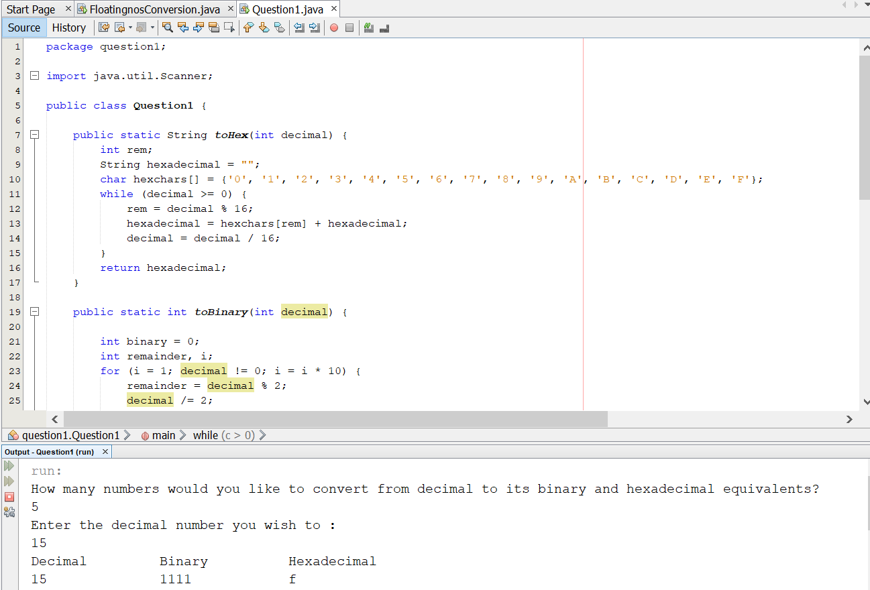

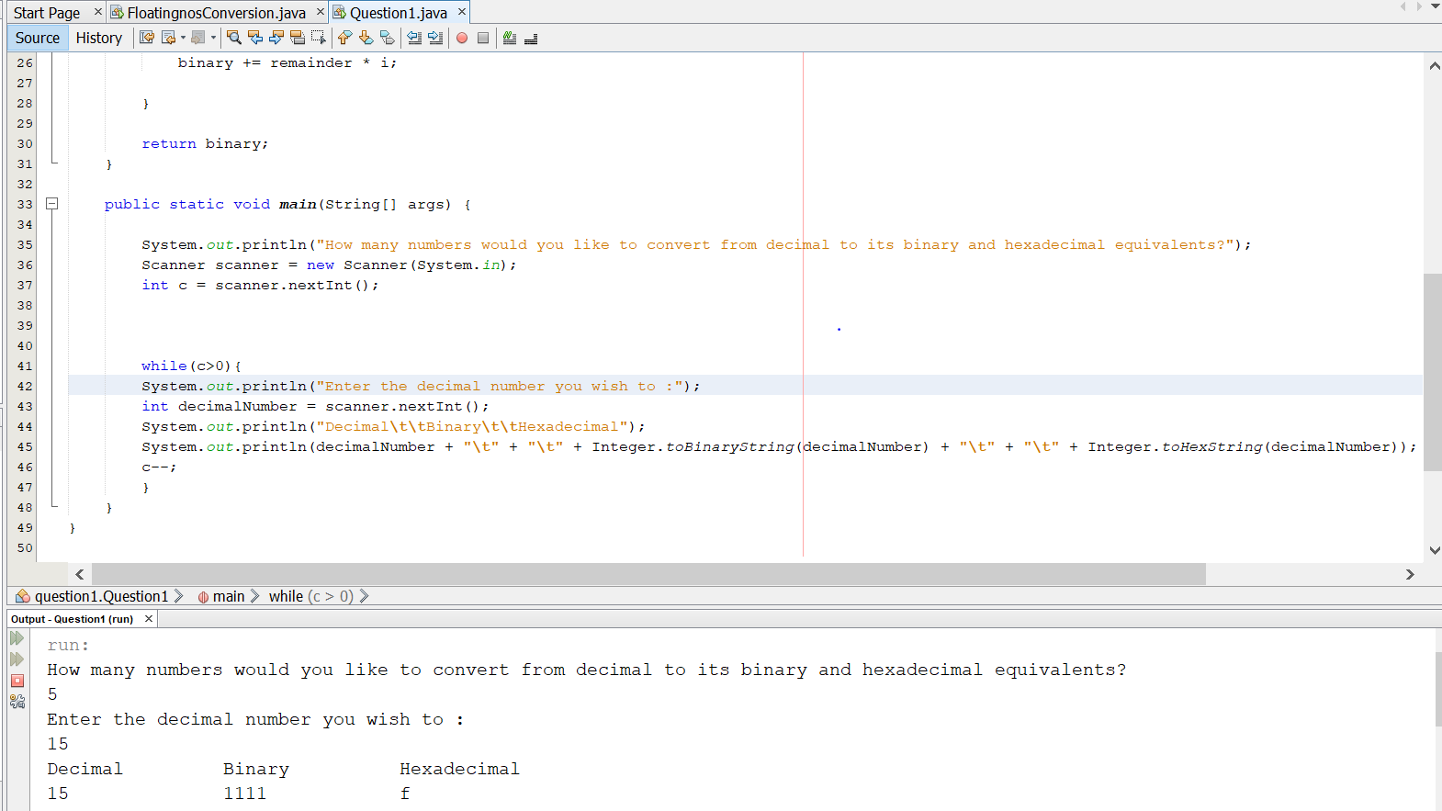

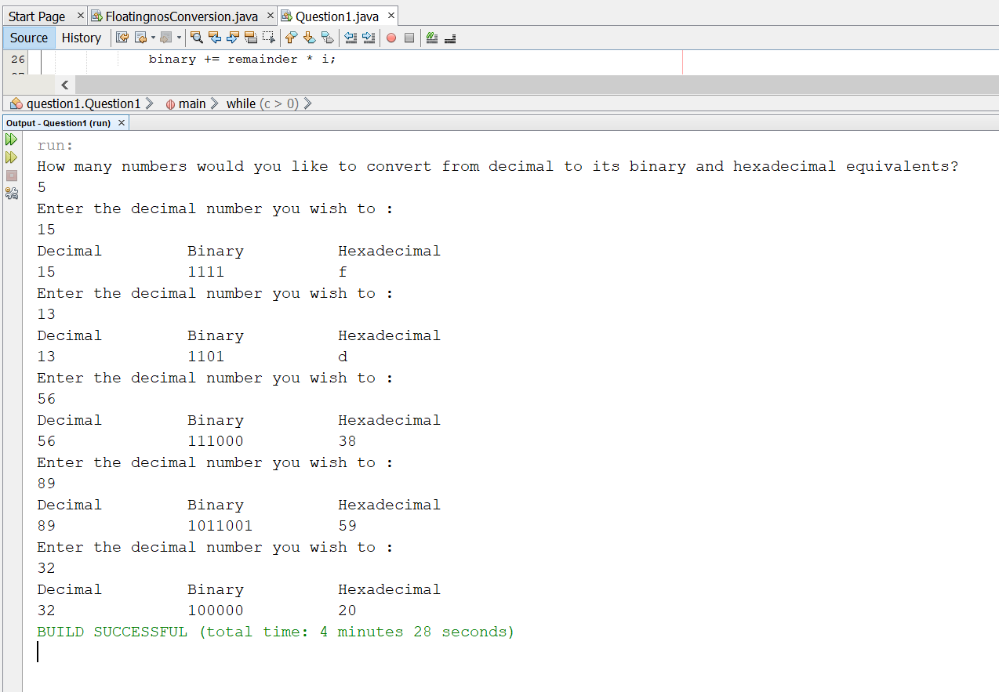

As a bonus, we implemented number one using C++.

**Screenshot to demonstrate that the program runs successfully on the command prompt**

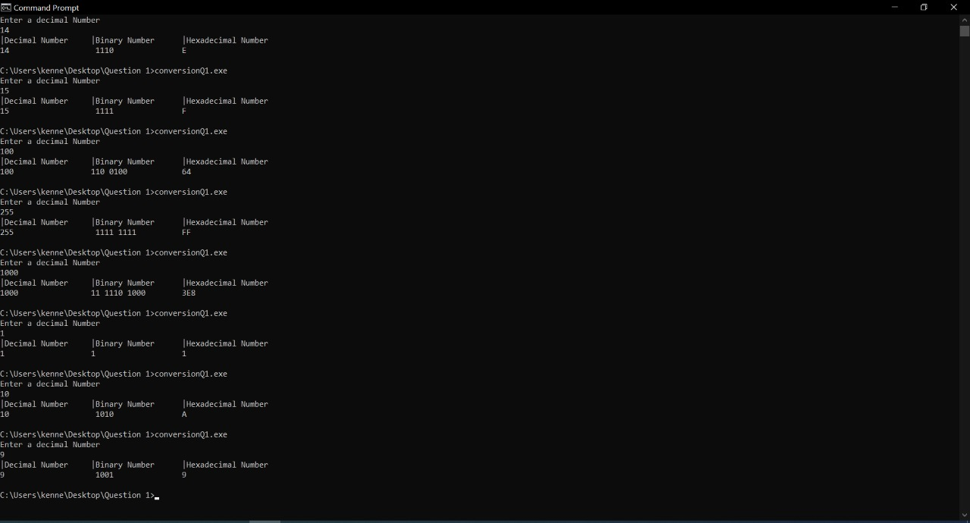

1. Write a program (Java or C++) to convert from decimal notation to binary notation for thirty (30) randomly generated floating-point numbers with at most three decimal points e.g., 123.875. Your result should give a list of randomly generated numbers, resulting binary notation and remarks column having exactly or approximately (with at most five (5) decimal points) remark. Table Q1 (b) shows a sample of an expected results for 11.81 and 21.25, respectively.

**Copy pasted result of the table generated once the code is run.**

run:

run:

S/No. | DecimalNo. | Binary No. | Remarks.

1 | 27.462 | 11011 .01110 | Approximate

2 | 79.457 | 1001111 .01110 | Approximate

3 | 57.801 | 111001 .11001 | Approximate

4 | 31.655 | 11111 .10100 | Approximate

5 | 47.418 | 101111 .01101 | Approximate

6 | 51.391 | 110011 .01100 | Approximate

7 | 52.795 | 110100 .11001 | Approximate

8 | 95.303 | 1011111 .01001 | Approximate

9 | 17.43 | 10001 .01101 | Approximate

10 | 60.55 | 111100 .10001 | Approximate

11 | 34.867 | 100010 .11011 | Approximate

12 | 15.681 | 1111 .10101 | Approximate

13 | 11.023 | 1011 .00000 | Approximate

14 | 66.631 | 1000010 .10100 | Approximate

15 | 78.366 | 1001110 .01011 | Approximate

16 | 81.75 | 1010001 .11 | Exactly

17 | 24.034 | 11000 .00001 | Approximate

18 | 50.835 | 110010 .11010 | Approximate

19 | 57.955 | 111001 .11110 | Approximate

20 | 84.257 | 1010100 .01000 | Approximate

21 | 90.322 | 1011010 .01010 | Approximate

22 | 45.458 | 101101 .01110 | Approximate

23 | 74.888 | 1001010 .11100 | Approximate

24 | 12.09 | 1100 .00010 | Approximate

25 | 23.392 | 10111 .01100 | Approximate

26 | 84.257 | 1010100 .01000 | Approximate

27 | 32.761 | 100000 .11000 | Approximate

28 | 80.481 | 1010000 .01111 | Approximate

29 | 39.166 | 100111 .00101 | Approximate

30 | 93.23 | 1011101 .00111 | Approximate

BUILD SUCCESSFUL (total time: 0 seconds)

**Screenshots to demonstrate that the program runs successfully on Netacad IDE.**

